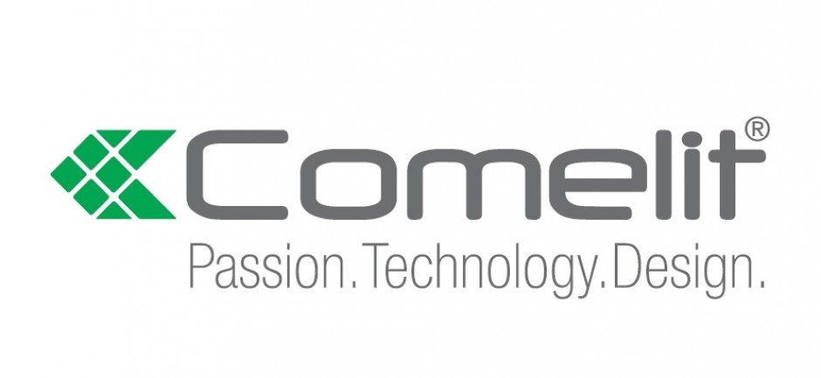
Comelit Premiers Integrated New Solutions at The Security Event

Comelit Group, as a founder Partner to The Security Event, is excited to return to exhibit with the launch of latest integrated solutions, comprising an array of smart security and fire safety systems for residential and commercial premises.

On stand 3a/B10, Comelit will be presenting its new Logifire addressable panel, which has been designed to offer a simple to install, fire safety solution that is compliant to latest standards. It is complemented with a new range of detectors, offered with award winning designs to ensure systems blend with their surroundings.

Exclusively previewed at The Security Event is Comelit’s latest alarm management software, Horus, which presents an innovative platform that integrates intruder alarm, fire detection, video surveillance and door entry into a single software capable of targeting alarm management.

Comelit will be showcasing its latest updated home automation systems, including Maxi Manager with Android, alongside smart integration with Amazon Alexa, Google Home and Echo Show.

Says Francesca Boeris, Managing Director Comelit Group UK: “Whilst we have been under enormous pressure as a result of the global pandemic, behind the scenes at Comelit, we have been working on some really exciting integration products and services that really go to the heart of fire safety and smart security design.

“We are thrilled with the live opportunity at The Security Event to present our latest solutions. This is not only in their capability to seamlessly operate for the benefit of homeowners and business property owners, but also with due consideration to installers looking for simple ways to offer this smart technology. When combined with our mobile first possibilities, we believe we have the perfect solution.”

Visitors to the stand will have the opportunity to see live demonstrations of Comelit’s latest wireless intruder alarm system, Secur Hub, which is designed to seamlessly operate with its inclusive app technology.

Natively connected to the Comelit Cloud, which includes both WiFi and LAN connectivity, Secur Hub operates a high-performance two-way radio link between the control panel and the sensors.

Also on show will be Comelit’s renowned door entry systems, including its newest modular stylish panel, Ultra, alongside mini handsfree WIFI monitor, Icona, Switch and 316 sense and touch entrance panels together with iconic interconnection systems VIP and Simplebus.

Comelit representatives will be on hand to demonstrate how each system can operate through Comelit’s new ‘My Comelit’ APP, allowing installers easier control over their installations.

Francesca concluded: “The Security Event is a perfect, long-awaited, platform for Comelit to not only present its all-encompassing product portfolio with integration capability, but also demonstrate to visitors the ease of installation and smart mobile-first upgrade opportunities. This is all completed to the highest of industry standards and without compromising on the style and aesthetics that is synonymous with the Comelit brand.”

For more information on Comelit Group or its product range, please visit stand BA/310 at The Security Event, taking place between 7 – 9 September 2021 at The NEC Birmingham. Further details can be found at www.comelitgroup.com

-ends-

About Comelit
Comelit has been a leading global manufacturer of video and audio door entry products for more than half a century. The company is globally recognised for its stylish solutions that continue to evolve as technology moves forward.
Included in its extensive portfolio, designed and manufactured exclusively by Comelit, is class-leading video door entry panels and monitors, fire detection systems, intruder alarm, CCTV, IP and analogue high-definition surveillance solutions, together with smart home automation systems.

Within Comelit’s recently launched fire division, systems are offered with the same emphasis on high quality and accredited standards, without compromising on aesthetics, for main panels and detectors together with a range of accessories.

Comelit products are sold in over 80 countries worldwide through an extensive technical and sales network. Quality and future-proofing is guaranteed by cutting-edge technological research, ongoing optimisation of functional and application processes and chic Italian design.

